FALL
BANQUET
ur annual banquet is just around the corner! The 23rd Annual Chosen Vision Banquet and LIVE Auction event will be held on Friday, October 24th at the Eagle Eye Banquet Center, beginning at 6 PM. Because of you, our residents are truly blessed!
We have several cash prizes for our upcoming drawing associated with this year's event:
1st Prize: $500 cash 2nd Prize: $250 cash
3rd Prize: $100 cash
PLUS amazing LIVE auction items
AND silent auction baskets!
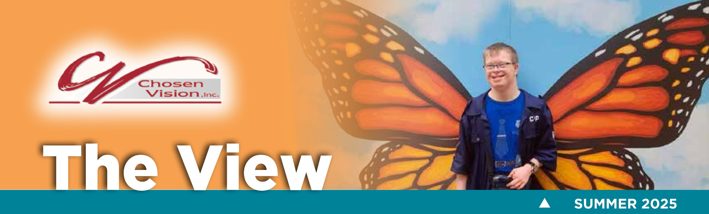
If you'd like to RSVP OR If you are unable to attend, purchasing raffle tickets is one way to support our efforts. Contact Janette @ 517.420.6975.
NOTE: sponsors and donors will be acknowledged in our banquet program and receipts mailed post-event.

SILENT AUCTION

BASKET IDEAS
Chosen Vision has always been blessed with an abundance of silent auction donations for our fall banquet fundraiser. Below are some creative ideas you may wish to purchase to donate. If you have questions about silent auction items, please contact Tina (chosenvision@comcast.net) or Janette (janettep@chosenvision.org).
Chocolate Lovers | Kids Funday
Cooking | Pamper Her
Coffee Lovers | Baking
Picnic Basket | Just For Him
Sports Fan (any sport) | BBQ
Dog/pet | Tailgate Fun
Board Games | Movie Theatre Package
Cocktail Basket | Cat/pet


Giving is not just about making a donation, it's about
making a difference.
A VIEW FROM THE CHAIR -

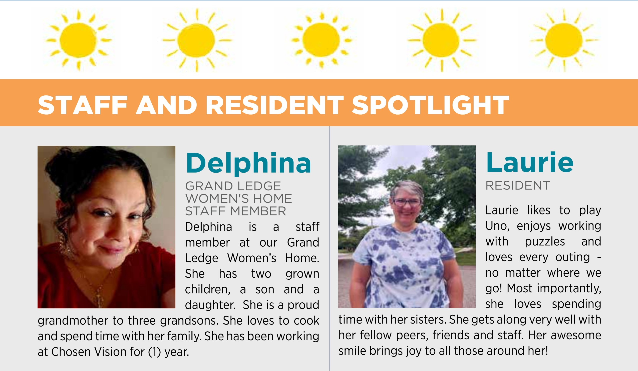
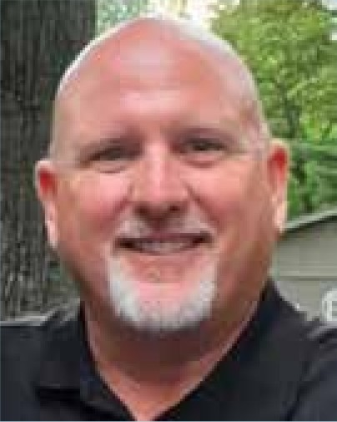
e wrapped up another successful golf marathon fundraiser on June 6th. A total of 49 golfers hit the Hawk Hollow Championship Golf Course starting at 7am. Chosen Vision residents, staff, and volunteers helped bring a lot of joy and festivity to the day. All told, we raised $160,000 for Chosen Vision. This was our 14th year hosting the golf marathon, and we have raised over $1 million for CV through this fundraising event. Thank you to our generous donors, golfers, volunteers, and staff who made this possible. We hope to see everyone next year on June 12, 2026, at Hawk Hollow as our 15th Golf Marathon is already being planned!
Regarding the uncertainty surrounding government funding subsidies; the Chosen Vision Board of Directors is keeping a keen eye on all the developments and subsequent changes. Approximately 67% of our budget is received through federal and state funding. We have elected to take a conservative approach and not react to speculations. Once definitive guidelines are in place, we will adjust as needed. We will continue to keep you updated.
We are very fortunate to have a steady and reliable staff. Our caretakers continue to give great care to each one of our residents and we are thankful.

If you are interested in joining the Chosen Vision Board of Directors, please email me at cpilditch@yahoo.com. We have two openings and are looking to fill those board seats with someone with expertise in either financial, legal or HR experience.
We are grateful for your partnership!
Craig Pilditch
Board Chairman
Chosen Vision


FALL 
L IVE AUCTION
We are excited to share (4) travel packages that will be available at this year's Fall Banquet!
***Additional opportunities for Live Auction Items will be available***
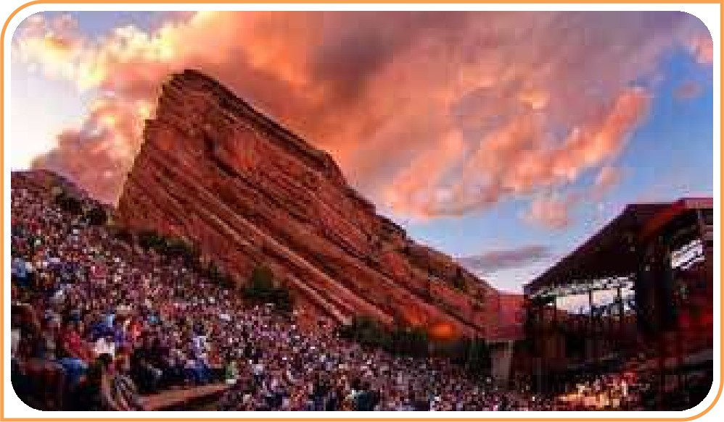

Notes of Nashville
(2) Nights: Starting Bid $1,850
Concert at Analog, Dinner, 2 Night Stay at
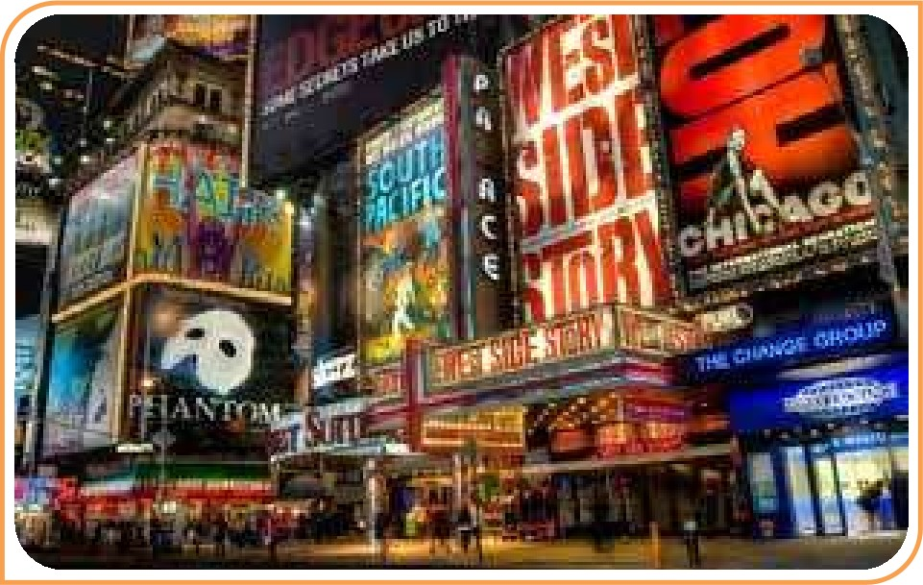
Hutton Hotel

Broadway Bound
- Nights: Starting Bid $2,495
Choice of Broadway Show and Dinner at a
Popular New York Restaurant with 2-Night
Stay for (2)
The Red Rocks Amphitheatre
- Nights: Starting Bid $ 2,800
3 Night Stay in Denver and Dinner for (2)
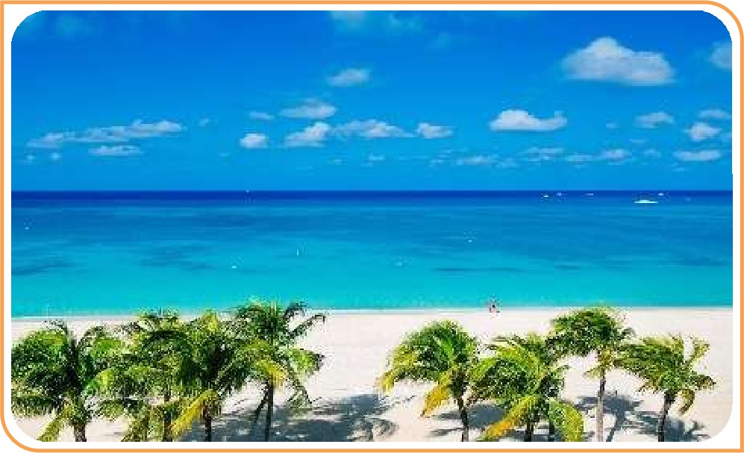

Dominican Delight
All Inclusive in a Family Duplex for up to (4): Starting Bid $3,450, Playa Bavaro - Punta Cana

FOR MORE INFORMATION, PLEASE VIEW THE LINKS!
Notes of Nashville: https://www.auctionpackages.com/experience/notes-of-nashville
The Red Rocks Amphitheatre: https://www.auctionpackages.com/experience/the-red-rocks-amphitheatre
Broadway Bound: https://www.auctionpackaqes.com/experience/broadwav-bound
Dominican Delight: https://www.auctionpackaqes.com/experience/all-inclusive-dominican-familv-qetawav

TRIPS CAN BE USED UP TO 2 YEARS AFTER PURCHASE
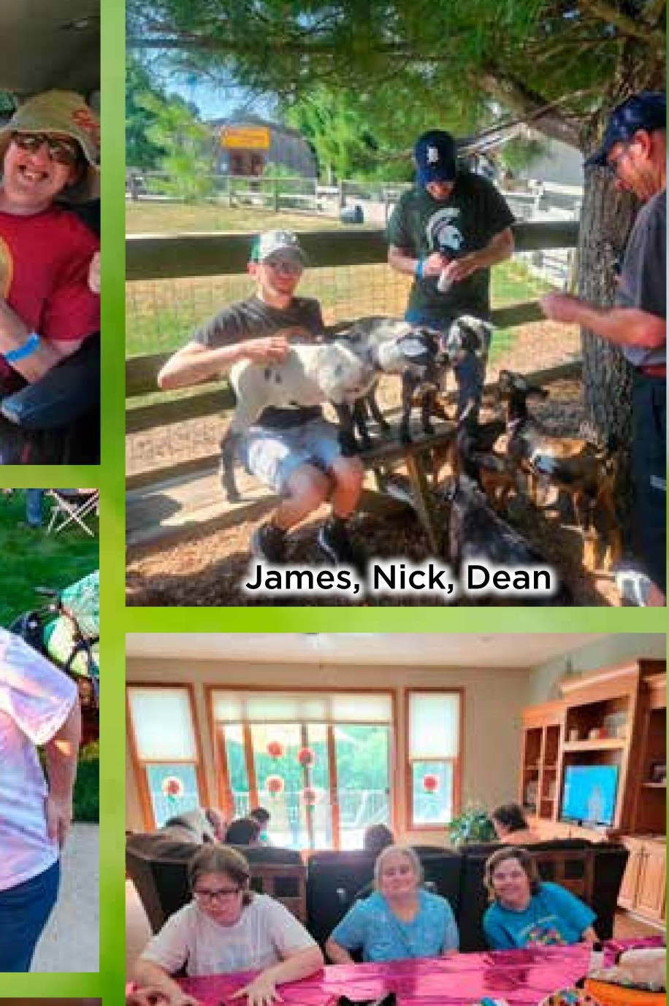
Jackson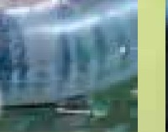Michael

Shane Beth and Liz
Liz,

Adrienne
Caleb, Gabe, Matthew, Mitchell
Danielle
Shane, Terry, Steve, Alex, Billy Susan and Adrienne
|
Billy,Uackson
Jordan, Jackson, Dean,
Bill
James (Mr. Grinch), Nick
Valerie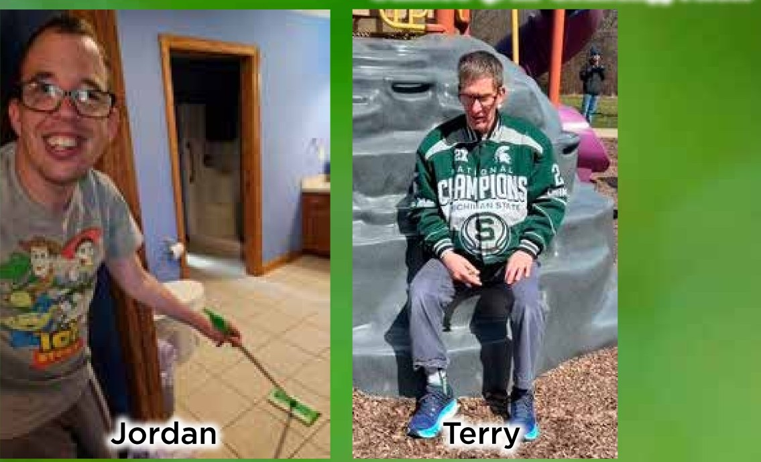Terry
Erika
Colleen, Liz, Erika, Beth
Amy
Dean Steve and Nick
5:15 a.m. came much too quickly to start the first full day,
Matt came to action but Caleb loved our digs so much, in his bed he wanted to stay. Ignoring the delay but bribing him with breakfast seemed to be the best action to take, then low and behold it became apparent that his sleepiness was really quite fake.
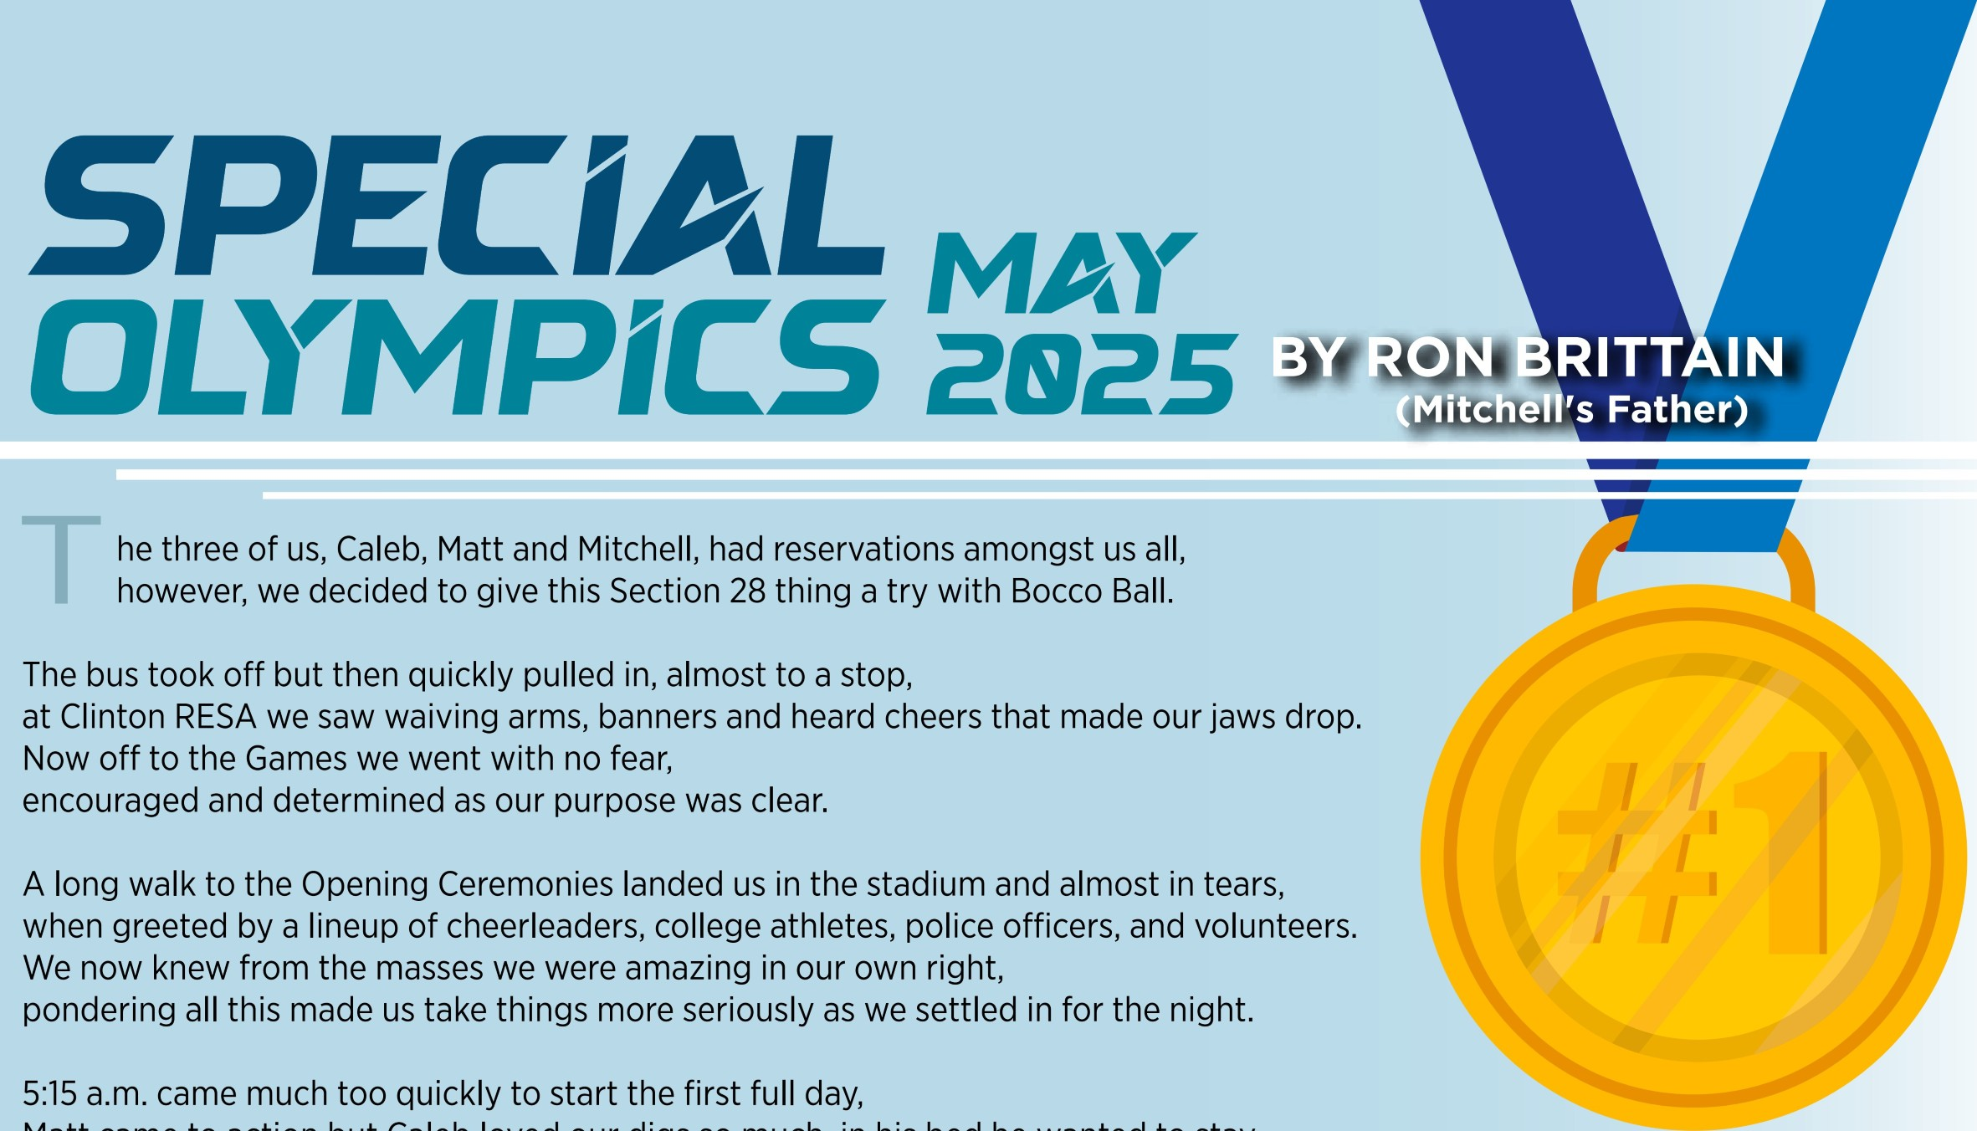
So upward and onward with a long walk to the field we did go, though a little chilly and windy we tried not to miss any ball our team did throw.
Throughout each day we stayed patient and clapped for each athlete we knew, as the medals around our necks continually grew.
We had enjoyed great 'guy' times, teasing and making weird noises that only men do, but we knew we were ready to go home as we competed well and were now through.
Although the time had come for us to leave for this year, we knew we'd be back again with some new friends that we now hold dear!
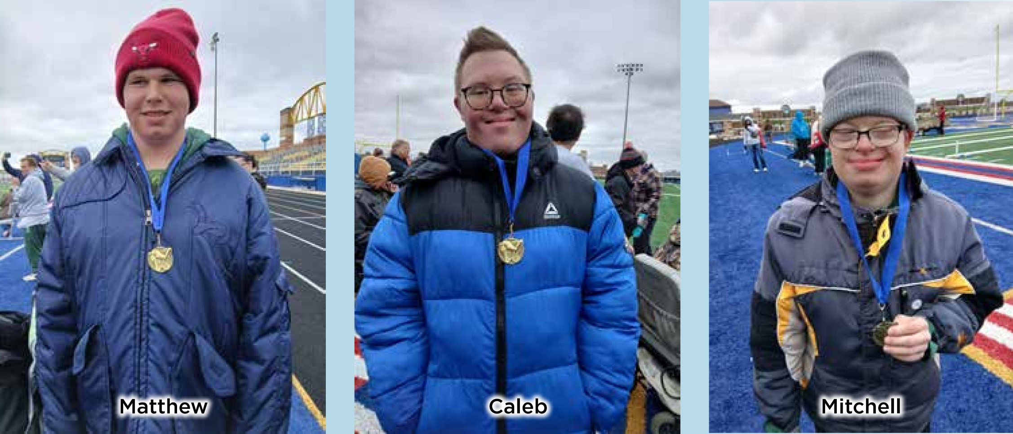

NEEDS
AND
TREAT
S
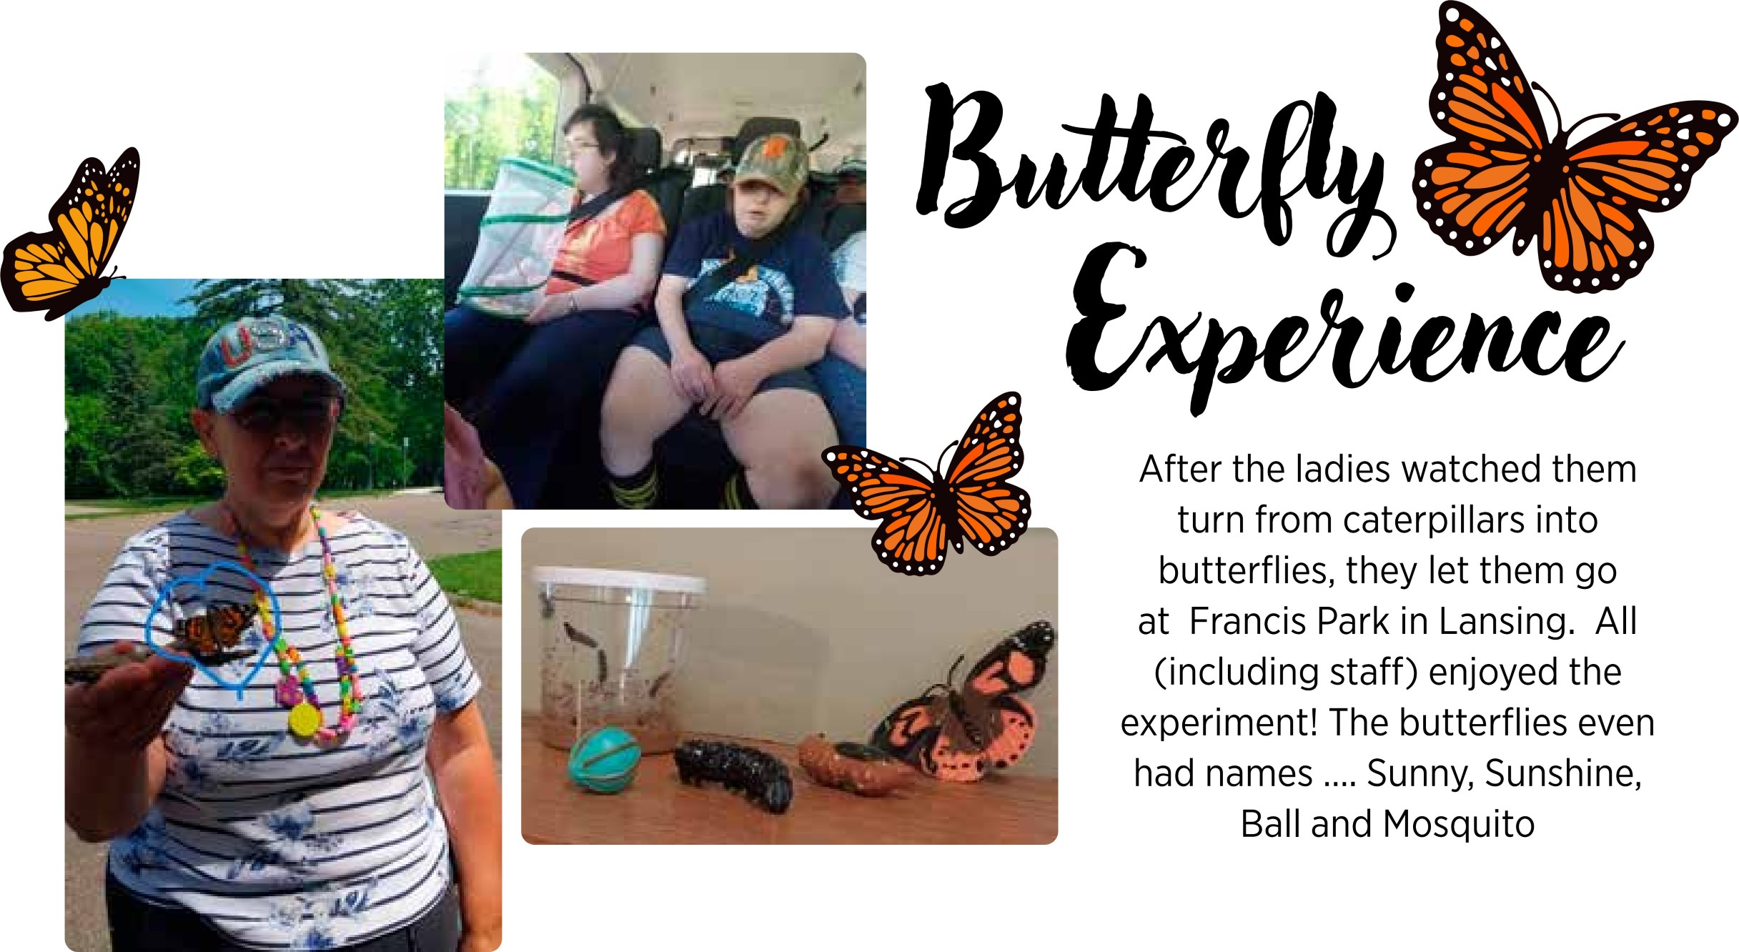


Presorted Standard
U.S. Postage
PAID
Lansing, Ml
Permit No. 689
P.O. Box 281
DeWitt, Ml 48820
Phone: (517) 410-6541
Email: chosenvision@comcast.net www.chosenvision.org


